Polysync User Manual & Setup Training Guide
Document type: End-user setup manual & hands-on training
Edition: 1.0 · June 2026
Audience: Tenant administrators, data engineers, and operators
Scope: End-to-end setup — Secret Vault → Platform → Job → Task → Dependencies → Schedules → Monitoring
Prerequisite role: Admin (Setup is Admin-only); Operators have Monitor access

Table of contents
- Introduction & concepts
- Signing in and the Setup studio
- Step 1 — Create a Secret Vault (Key Vault)
- Step 2 — Create a Platform
- Step 3 — Import a Job
- Step 4 — Create a Task
- Step 5 — Define dependencies
- Step 6 — Add schedules
- Step 7 — Monitor executions
- Troubleshooting
- Glossary

1. Introduction & concepts
Polysync orchestrates data and AI workloads across clouds from one workspace. Five concepts drive every setup, and you build them in order:
- Secret Vault — where credentials live (Azure Key Vault, AWS Secrets Manager, Google Cloud Secret Manager, HashiCorp Vault, or Polysync's managed central vault). Platforms reference vault secrets so no credential is stored in plain configuration.
- Platform — a connection to a cloud execution service (Azure Data Factory, Databricks, Functions, Logic Apps, and more).
- Job — a resource discovered on a platform (e.g., an ADF pipeline or a Databricks notebook) imported into Polysync.
- Task — a configured run of a job, carrying parameter values, dependencies, schedules, and retry policy. Tasks are what actually execute.
- Schedule / Monitor — when tasks run (CRON) and how you observe them.
The dependency chain is: a vault feeds a platform → a platform yields jobs → jobs become tasks → tasks link via dependencies and fire on schedules → everything is watched in monitoring. Follow the seven steps below in sequence.

2. Signing in and the Setup studio
- Browse to your Polysync workspace and sign in with Microsoft Entra ID.
- Open Setup from the left nav. The studio is a two-pane layout: the category tree (Secret Vault, Platform, Job, Task, Contention Profile) on the left, editor tabs on the right.
- Create objects two ways: click + New inside a category, or right-click (⋯) a category and choose New. Selecting an object opens it in an editor tab; multiple tabs can be open at once and Save All commits them.
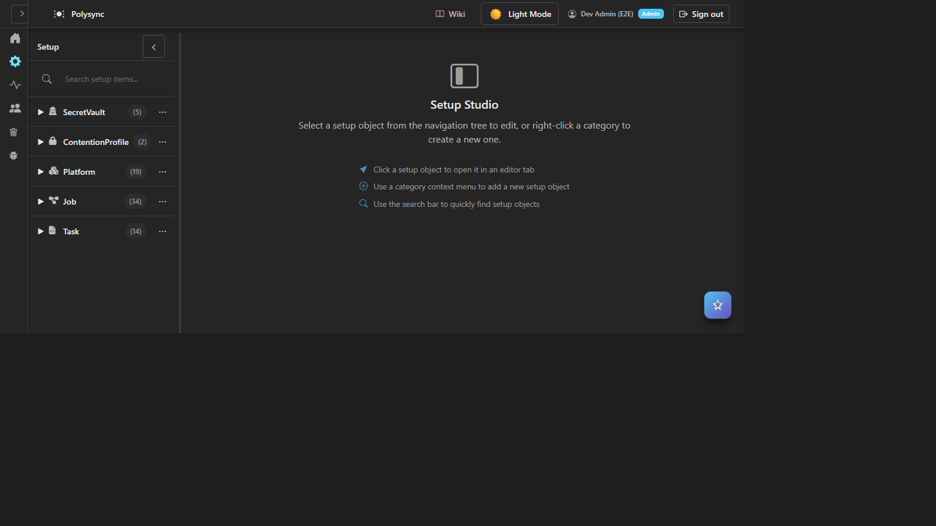
The Setup studio: category tree on the left, editor canvas on the right

3. Step 1 — Create a Secret Vault (Key Vault)
The vault comes first because every platform reads its credentials from a vault. Polysync also offers a managed central Key Vault if a customer has no vault of their own.
- In the Setup tree, expand SecretVault and click + New (or open an existing vault to follow along).
- General tab: enter a Secret Vault Name and choose a Secret Vault Type — Azure Key Vault, AWS Secrets Manager, Google Secret Manager, or HashiCorp. Each type shows an inline link to its setup guide.
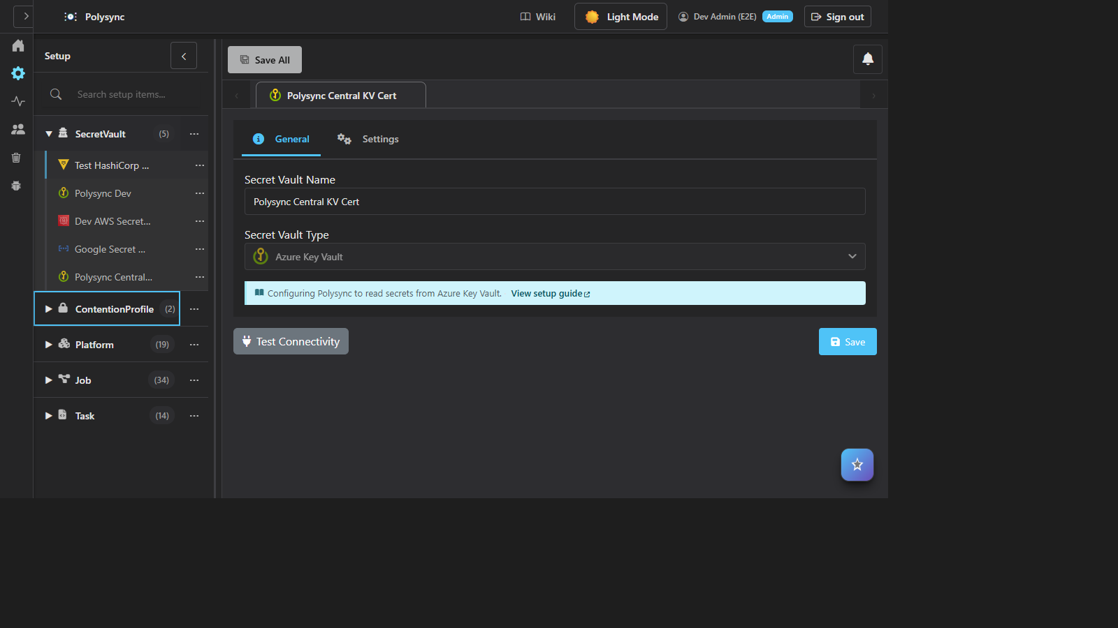
Secret Vault editor — General tab with type Azure Key Vault
- Settings tab: enter the vault URL and authentication. For Azure Key Vault choose Managed Identity (recommended), Service Principal, Certificate, or Default Credential. Secret values can be stored in Polysync's central key vault.
- Click Test Connectivity. Resolve any error, then Save.
Tip: prefer Managed Identity wherever possible — no secret to rotate, and access is governed by Entra ID.

4. Step 2 — Create a Platform
A platform is the connection to the engine that runs work. Jobs are discovered from it.
- Expand Platform → + New.
- General tab: enter a Platform Name and pick a Platform Type (e.g., Azure Data Factory). The note links to a type-specific setup guide.
- Settings/Attributes tab: enter connection details (subscription, resource group, factory/workspace) and bind credentials to the vault secret from Step 1.
- Click Test Connectivity to validate; then Get Jobs to discover resources, and Save.
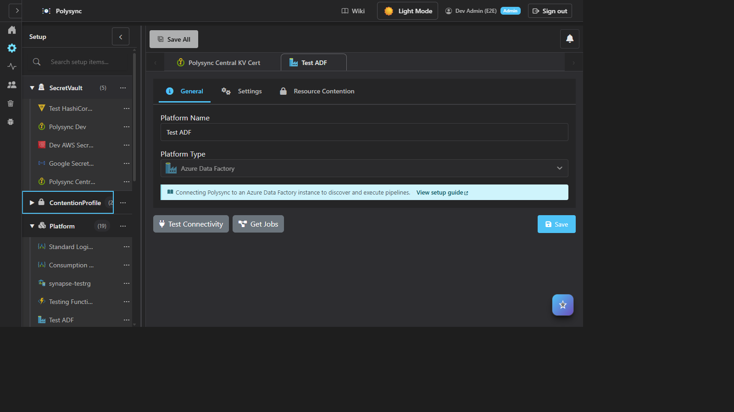
Platform editor — Azure Data Factory with Test Connectivity and Get Jobs

5. Step 3 — Import a Job
A job is a discovered resource. Use Get Jobs on the platform, or open a job to review it.
- From a saved platform, click Get Jobs and pick the pipeline/notebook/function to import. Parameters are extracted automatically.
- General tab: review name, platform, and job type. Parameters tab: confirm parameter names/types. Settings tab: defaults.
- Use Execute Now to smoke-test, Create Task to turn it into a runnable task, or Sync Parameters after platform changes. Click Save.
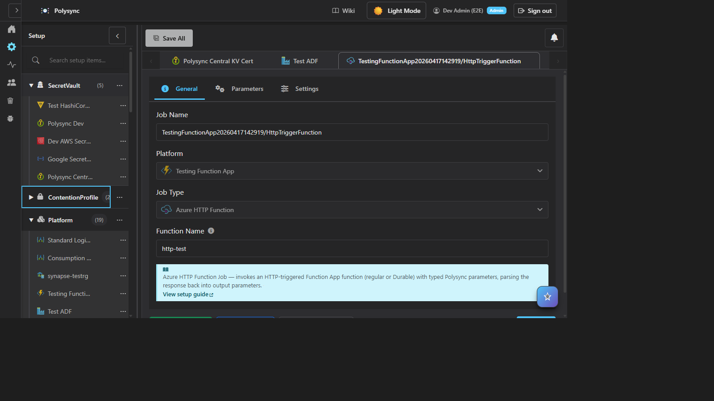
Job editor — General/Parameters/Settings with Execute Now and Create Task

6. Step 4 — Create a Task
A task is a configured run of a job — the unit that executes.
- Expand Task → + New (or click Create Task from a job).
- General tab: choose Platform, Job Type, and the Job. Set parameter values for this run.
- Settings/Runtime tab: priority, retry policy, contention profile.
- Save. The task now has Dependencies and Scheduling tabs.
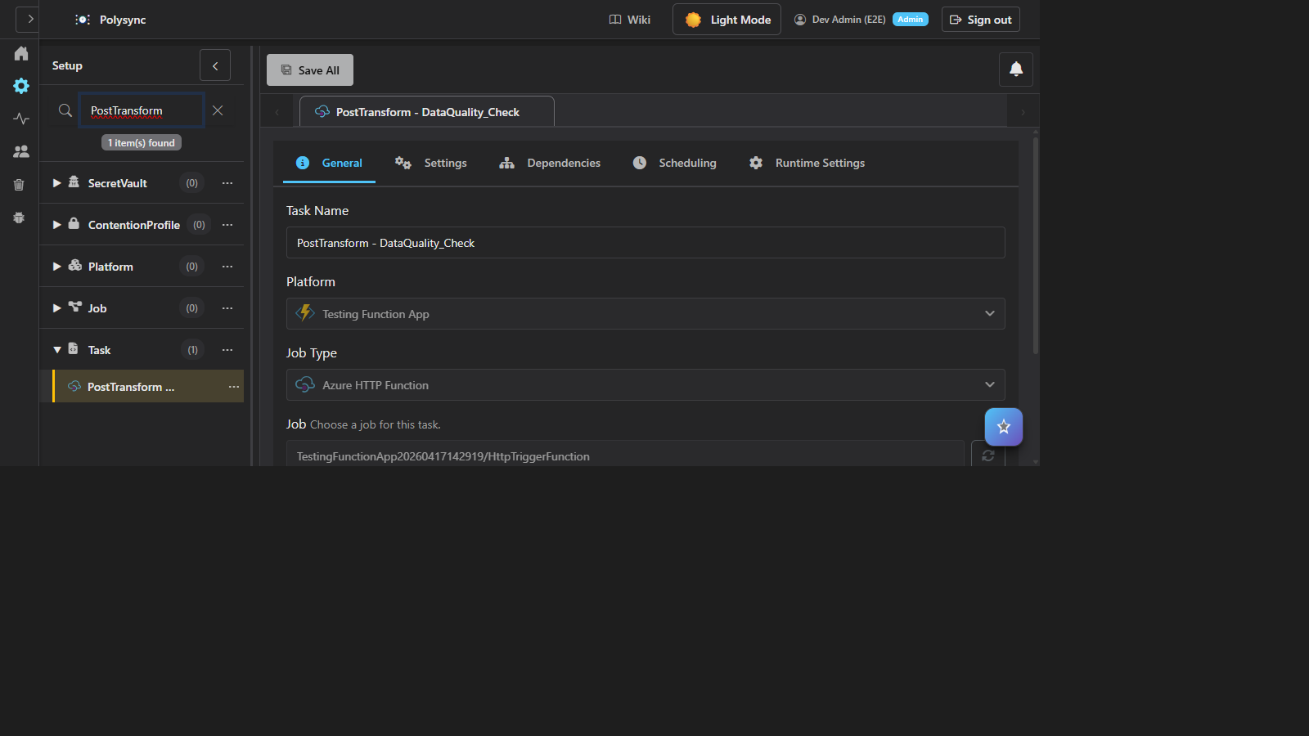
Task editor — General tab with Platform, Job Type, Job, plus Dependencies and Scheduling tabs

7. Step 5 — Define dependencies
Dependencies sequence tasks across platforms; Polysync detects cycles before any run.
- Open the task's Dependencies tab → + Add Dependency.
- Choose parent tasks and a trigger: On Success, On Failure, On Completion, or On Skipped. Map outputs to child inputs if needed.
- The Dependency Visualization renders the live DAG; toggle Direct/Recursive to inspect the full chain. Cycles are blocked.
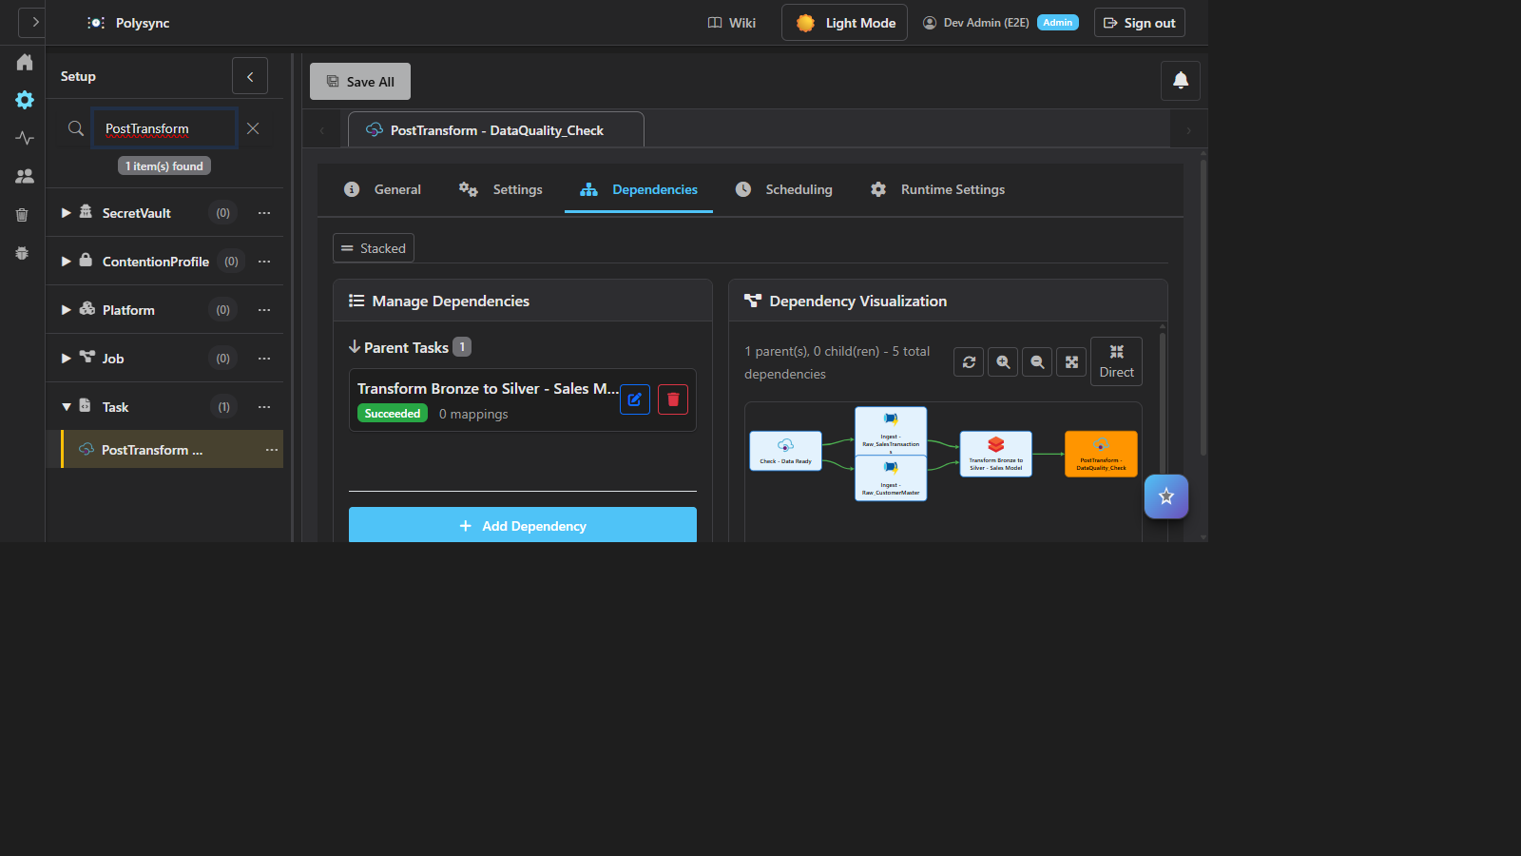
Dependencies tab — parent task with trigger and live DAG visualization

8. Step 6 — Add schedules
- Open the Scheduling tab → + Add Schedule.
- Choose a frequency preset (seconds, minutes, hours, daily, weekly, monthly) or Custom CRON; pick a Time Zone. The builder shows a plain-English summary, the CRON string, and the next execution times.
- Tick Active and Save. Multiple schedules per task are supported.
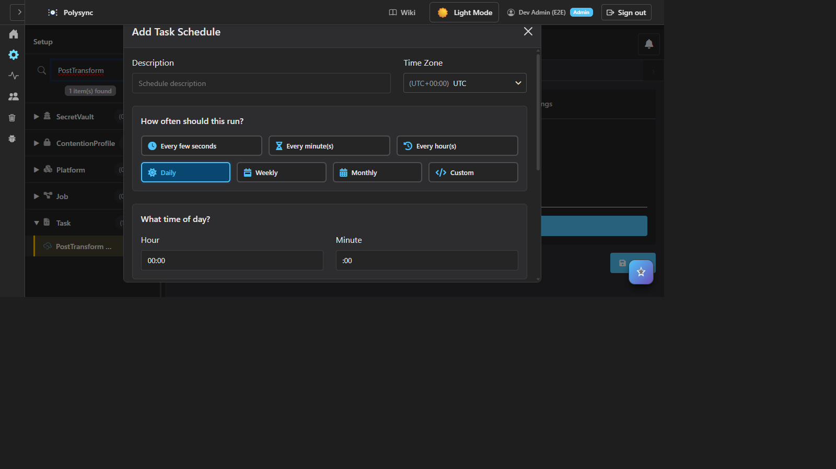
Schedule builder — frequency presets, timezone, summary, and next-run preview

9. Step 7 — Monitor executions
- Open Monitor. Tabs: Scheduler Status, Dispatcher Status, Task Execution, Analytics, Usage & Billing.
- Task Execution shows totals (Running/Completed/Failed), date-range filters, status/task filters, and a DAG view. Use Live to auto-refresh.
- Drill into a run to inspect logs; failed tasks honor retry policy and dependency triggers.
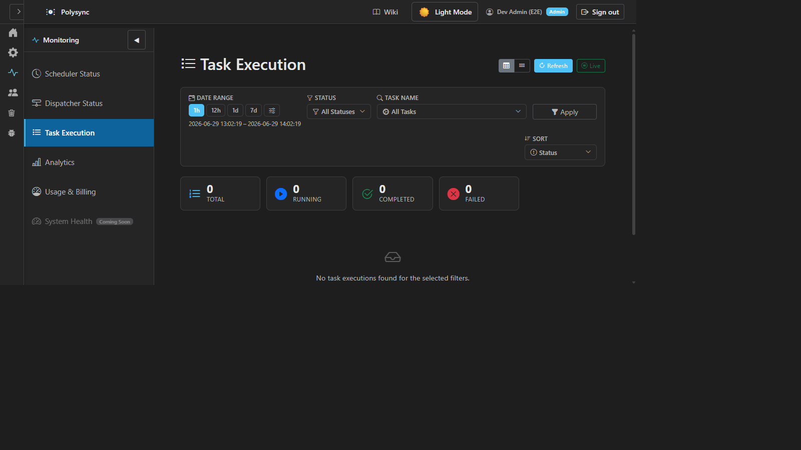
Task Execution dashboard — filters, status totals, and run list

10. Troubleshooting
- Connectivity fails: match the credential type to the platform; confirm the vault secret resolves; check network access to the resource.
- No jobs discovered: the credential needs list/read scope on the target resource.
- Schedule never fires: confirm Active, correct timezone, and that the dispatcher shows the task queued.
- Stuck: open Polysync Copilot — it reads current configuration and suggests fixes in context.

11. Glossary
- Secret Vault — credential store referenced by platforms.
- Platform — connection to a cloud execution engine.
- Job — discovered resource (pipeline/notebook/function).
- Task — configured, runnable instance of a job.
- Dependency — parent→child link with a trigger; forms the DAG.
- Schedule — timezone-aware CRON trigger.
- Dispatcher — resolves dependencies and executes tasks.

