Polysync Platform — CSP Partner Training & Enablement Guide
Document type: Partner training manual & enablement whitepaper
Edition: 1.0 · June 2026
Audience: Microsoft CSP partner sales, pre-sales, and technical consultants
Platform: Polysync — Multi-Cloud Data & AI Orchestration with built-in Copilot
Publisher: Polysync Data Solutions Pty Ltd · Member, Microsoft AI Cloud Partner Program
Distribution: Partner-confidential — for CSP enablement use

Table of contents
- Executive summary
- Problem definition — industry context
- Solution overview — what is Polysync
- Architecture overview
- Core features and capabilities
- Sales positioning guide for CSP partners
- Onboarding guide — step by step
- Partner enablement playbook
- Use cases and scenarios
- Security, compliance, and trust
- Conclusion & next steps
- Appendix A — glossary
- Appendix B — partner quick-reference card

1. Executive summary

1.1 Overview
Polysync is an enterprise-grade multi-cloud data and AI orchestration platform. It provides a single control plane for discovering, connecting, sequencing, scheduling, and monitoring pipelines, notebooks, functions, and AI workloads across 18 cloud services spanning Microsoft Azure, Google Cloud, and AWS — including Azure Data Factory, Databricks, Functions, Logic Apps, Synapse & Fabric, Azure AI Foundry & OpenAI, Google Cloud Composer, Vertex AI, AWS Glue/Lambda/Step Functions, and Amazon SageMaker. It is delivered as multi-tenant SaaS, transactable on the Azure Marketplace, and resaleable through the Microsoft CSP program.
The platform is metadata-driven: jobs, tasks, dependencies, and schedules are configuration rather than code. Customers keep their existing cloud tools and gain one place to orchestrate them — one dependency graph, one schedule calendar, one monitoring view, one identity and governance model, and a built-in AI assistant (Polysync Copilot) that answers setup questions and performs configuration actions.
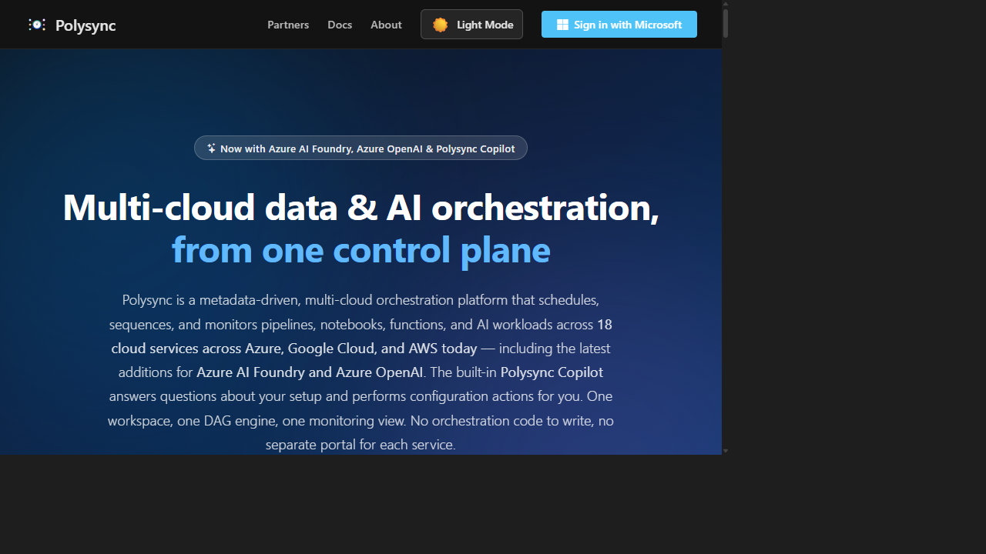
Polysync landing — multi-cloud data and AI orchestration from one control plane

1.2 Who this guide is for
This guide is written for Microsoft CSP partner teams:
- Sales — qualify accounts, lead value conversations, and resell with custom margin.
- Pre-sales / solution consultants — run discovery, demos, and proofs of concept.
- Technical consultants — onboard tenants, connect platforms, operate first pipelines.

1.3 Key outcomes
After completing this guide you will be able to:
- Explain the enterprise data-orchestration problem and why native tools fall short.
- Deliver a credible elevator pitch and handle the most common objections.
- Position Polysync against Azure Data Factory and other orchestration platforms.
- Provision Polysync from the Azure Marketplace and complete first-pipeline onboarding.
- Run a structured demo and POC, and identify ideal customer profiles.
- Speak confidently to security, compliance, and the Azure-native trust posture.

2. Problem definition — industry context
Enterprise data estates are multi-cloud by default — through deliberate strategy, acquisition, or shadow IT. A typical mid-to-large enterprise runs data and AI workloads across two or three hyperscalers plus SaaS and on-prem. The result is not more capability; it is more fragmentation. This section frames the problem CSP partners can resolve.

2.1 Fragmented data pipelines
Pipelines are built in whatever tool is closest to the data: Azure Data Factory for Azure SQL, Databricks for lakehouse transforms, Glue for AWS, Cloud Composer for GCP, plus hand-rolled Functions and scripts. Each has its own UI, triggers, and run history. There is no single dependency graph, so a Databricks job that must wait for an ADF copy is glued together with timers or polling. Cross-cloud sequencing becomes brittle tribal knowledge in a long wiki page no one wants to own.

2.2 Lack of governance and observability
Every tool logs to its own pane. To answer "did last night's run finish, and what failed?" an operator opens four consoles. There is no consolidated SLA, no single audit trail, and no unified lineage. Compliance teams cannot easily prove who ran what, when, and with which credentials.

2.3 Complex multi-cloud deployments
Each platform has its own auth (PAT, service principal, managed identity, ADC) and its own secret store (Key Vault, AWS Secrets Manager, GCP Secret Manager, HashiCorp Vault). Wiring these consistently per environment is slow and error-prone, and secret sprawl becomes a real security liability.

2.4 Operational inefficiency and manual process
Without unified scheduling, teams script CRON inside pipelines, retry by hand, and discover failures from stakeholders rather than tooling. Engineering time is lost to plumbing instead of data products. Onboarding a new pipeline can take weeks; a single cross-cloud dependency change can ripple unpredictably.

2.5 Structured problem statement
Enterprises have abundant best-of-breed cloud execution engines but no unifying orchestration, governance, and observability layer across them. The cost is fragmented pipelines, blind-spot operations, security risk from credential sprawl, and slow delivery. The market gap is a vendor-neutral control plane that orchestrates existing investments rather than replacing them.
Polysync exists to close that gap.

3. Solution overview — what is Polysync

3.1 Platform description
Polysync sits above the execution engines a customer already owns. Customers register their platforms, and existing jobs are discovered automatically with parameters intact. They compose tasks with dependencies, schedule them, and monitor everything from one tenant-isolated workspace. There is nothing to compile, package, or redeploy when configuration changes.

3.2 Core capabilities and philosophy
- Orchestrate, don't replace. Customers keep their pipelines; Polysync coordinates them.
- Metadata-driven. A Job is the resource discovered on a platform; a Task is a configured run with parameters, schedule, and dependencies. Configuration is data, not code.
- Unified dependency model. Cross-platform DAGs with On Success / Failure / Completion / Skipped triggers and automatic cycle detection.
- Single schedule and monitor plane. Quartz-based CRON, dispatcher queue, one execution history.
- Secure by default. Entra ID SSO, schema-per-tenant isolation, multi-vault secrets.
- AI-assisted. Polysync Copilot answers setup questions and performs configuration.

3.3 Differentiation from native tools
Native orchestrators are single-cloud and lock dependencies inside one engine. Polysync is cross-cloud: one DAG can chain an ADF pipeline → a Databricks notebook → an AWS Step Function, with secrets drawn from whichever vault each platform uses. It is a coordination layer, not another silo.

3.4 Position in the Microsoft ecosystem
Polysync is a transactable SaaS offer published by Polysync Data Solutions Pty Ltd and live on the Azure Marketplace. Through the Microsoft Cloud Solution Provider program, partners resell it, bundle it with their own services, and set custom margins via CSP private offers. Because it is metered on the commercial marketplace, customer spend can draw down a Microsoft Azure Consumption Commitment — a procurement advantage worth raising early with enterprise buyers. Partners earn recurring SaaS margin plus services around onboarding and integration.
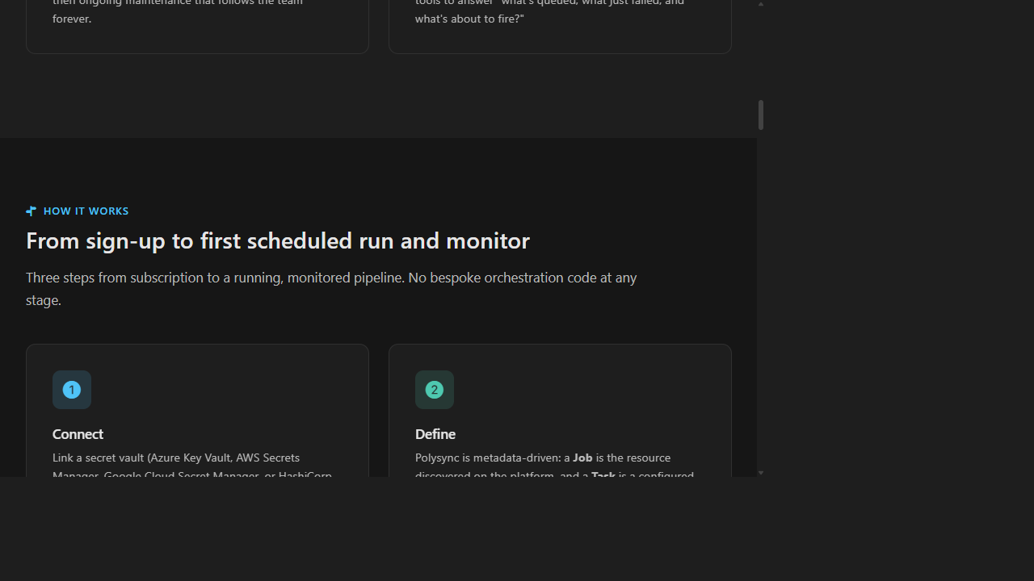
How it works — sign-up to first scheduled run and monitor

4. Architecture overview

4.1 Conceptual architecture
Polysync follows Clean Architecture across four layers (Domain, Application, Infrastructure, Presentation) deployed as three Azure App Services — Web, Cron, Dispatcher — over a shared multi-tenant SQL database, Key Vault, and Entra ID.
- Orchestration engine — the Cron service (Quartz.NET) evaluates schedules and triggers; the Dispatcher resolves dependencies, enforces concurrency/rate limits, retries transient failures, and executes tasks against target platforms.
- Integration layer — a provider factory abstracts each platform behind a common contract, so new services are added uniformly (provider pattern).
- Pipeline connectors — per-platform providers discover jobs, extract parameters, execute, and report run status.
- Identity & security — Entra ID OIDC for users; managed identities for services; multi-vault secrets (Azure/AWS/GCP/HashiCorp); schema-per-tenant isolation; Admin/Operator RBAC.
- Monitoring & logging — Application Insights + Log Analytics, plus in-app dashboards for Cron, Dispatcher, and task executions.

4.2 How it fits a typical Azure enterprise
Users sign in with their existing Entra ID. Polysync's App Services use managed identity to read Key Vault and reach Azure OpenAI for Polysync Copilot. Customer-owned platforms are called with tenant-supplied credentials; private resources reach SQL and Key Vault via VNet integration and private endpoints. Billing flows through the marketplace SaaS meter — no customer infrastructure to operate.

5. Core features and capabilities
The capabilities below are what separate a developer's local orchestrator from a platform that runs thousands of executions a week. Each is presented as feature, business value, and a concrete use case so partners can map them directly onto customer pain.

5.1 Pipeline orchestration (DAG dependencies)
- What it does: Composes tasks into cross-platform dependency graphs with On Success/Failure/Completion/Skipped triggers and cycle detection; renders visual DAGs.
- Why it matters: Replaces fragile timers and webhooks with deterministic cross-cloud sequencing.
- Use case: ADF ingest → Databricks transform → report, auto-sequenced; downstream skips on upstream failure.
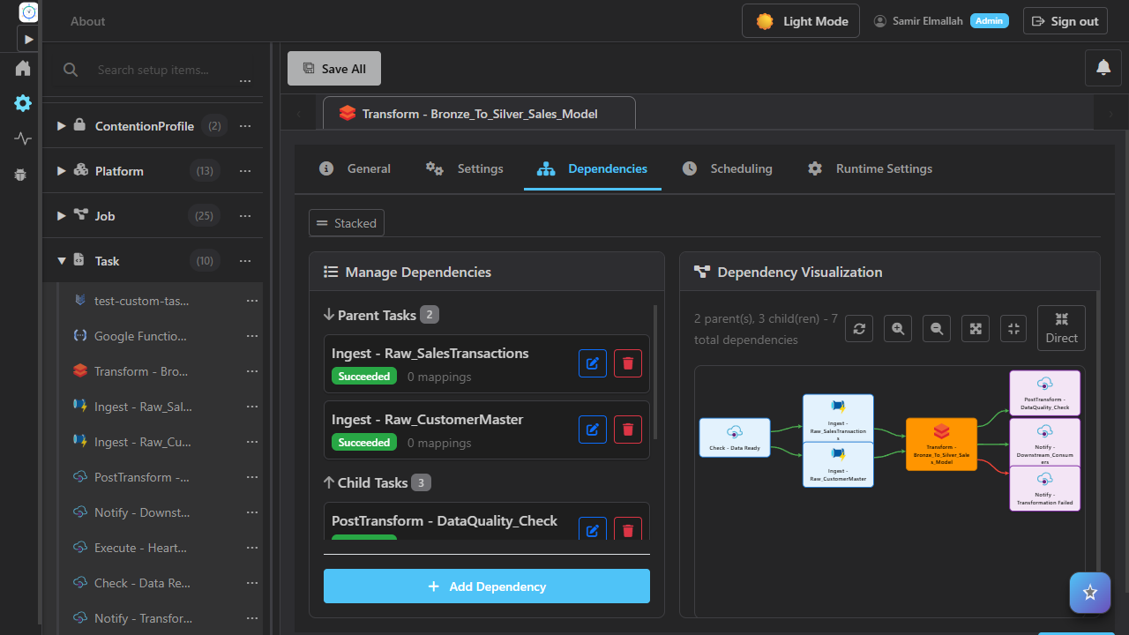
Cross-cloud DAG dependencies with conditional triggers

5.2 Multi-cloud integration
- What it does: Connects 18 services across Azure, GCP, and AWS with automatic discovery and parameter extraction.
- Why it matters: One pane for all engines; import in minutes, no rebuild.
- Use case: Import dozens of ADF pipelines and notebooks into a single managed catalog.
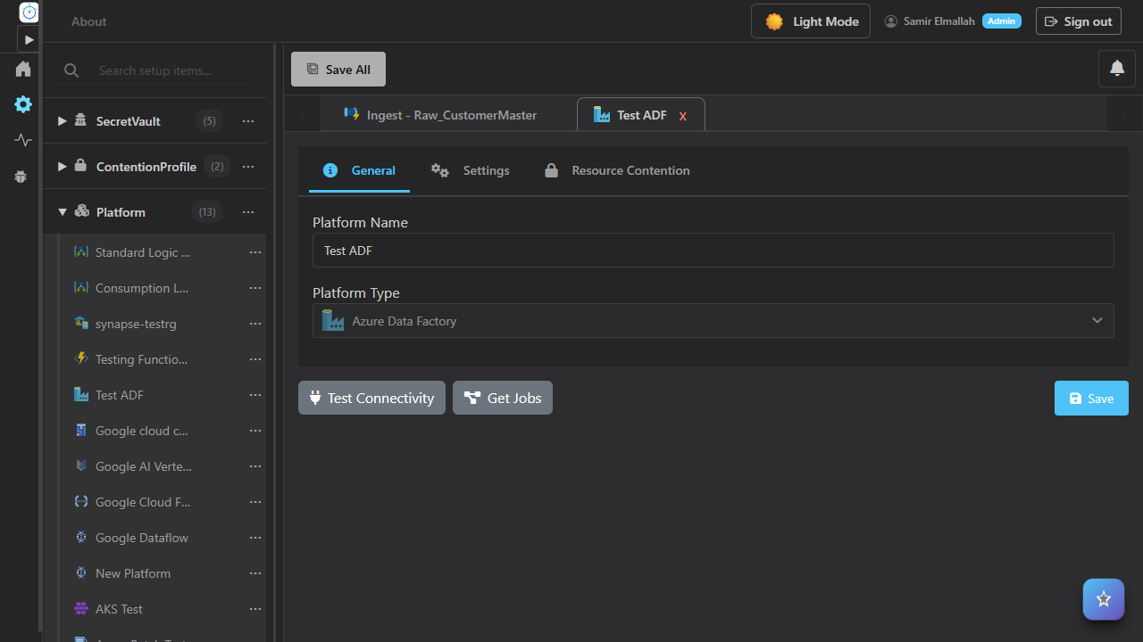
Setup studio — register platforms and import jobs

5.3 Automation & scheduling
- What it does: Timezone-aware Quartz CRON with a visual builder, human-readable summaries, multiple schedules per task, retries, and on-demand runs.
- Why it matters: Removes per-pipeline custom scripts and manual reruns.
- Use case: Nightly multi-cloud close with auto-retry — no scripts.
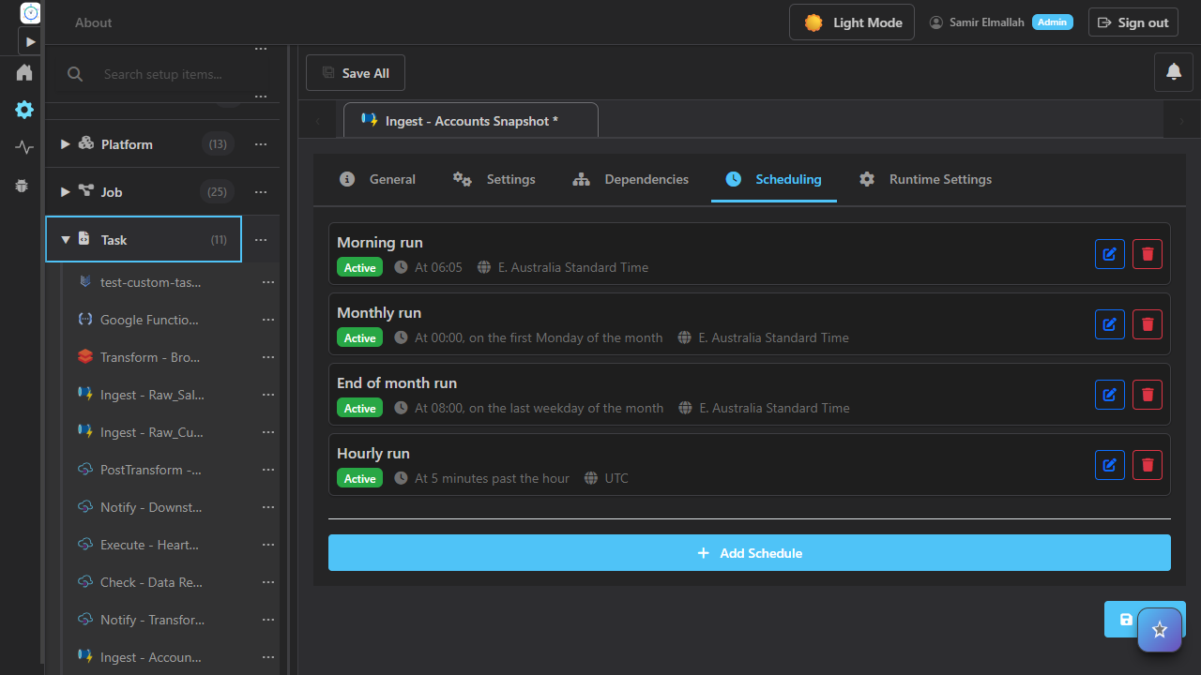
Visual CRON schedule builder

5.4 Observability & logging
- What it does: Dispatcher queue, schedule dashboard, execution history, and inline DAG in one view; App Insights telemetry and health checks.
- Why it matters: One SLA view; faster MTTR; audit-ready trail.
- Use case: Single screen for last night's runs and failure drill-down.
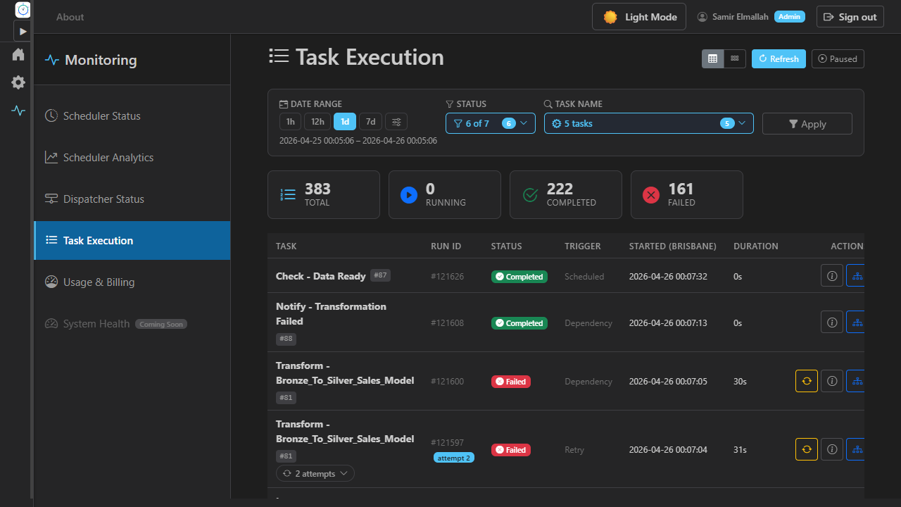
Live monitoring dashboard

5.5 Security & compliance alignment
- What it does: Entra ID SSO, schema-per-tenant isolation, multi-vault secrets, encrypted credentials, Admin/Operator RBAC, audit logging.
- Why it matters: Enterprise-grade, no credential sprawl, regulator-friendly.
- Use case: Per-tenant data residency for financial services.
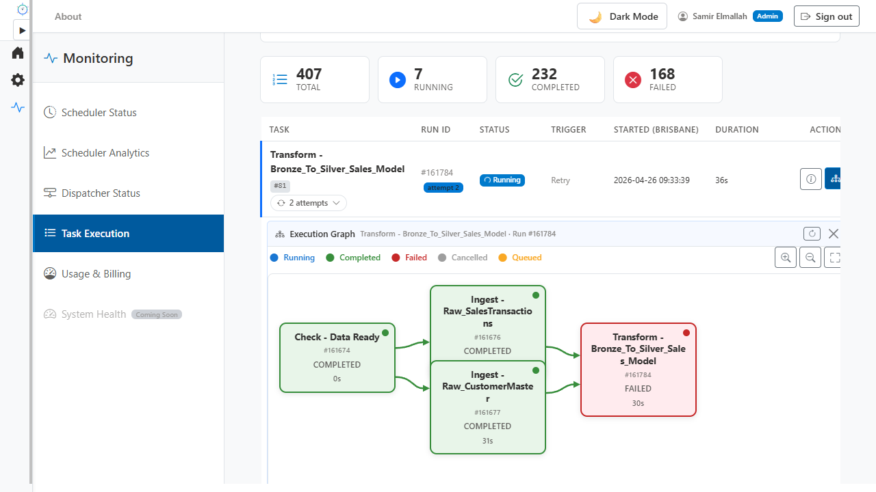
Configuration dashboard and dark mode

6. Sales positioning guide for CSP partners

6.1 Elevator pitch (30–60s)
"Most enterprises run pipelines across Azure, Databricks, AWS, and on-prem — each with its own scheduler and logs. Polysync is one control plane that orchestrates all of them: one dependency graph, one schedule, one monitor, all on Entra ID, with a built-in Copilot. They keep their tools and finally manage them together — buyable on Azure Marketplace, resaleable through CSP, and it counts toward MACC."

6.2 Key value propositions
Lead with the outcome, not the feature. Each proposition below pairs a customer benefit with the partner angle that funds your practice:
- Faster delivery. Teams report roughly 60% less effort building and maintaining ETL because cross-cloud sequencing is configuration, not code. Partner angle: more projects delivered per consultant, higher throughput.
- Less operational toil. Roughly 80% of manual scheduling and rerun overhead disappears once Quartz CRON, retries, and dependency triggers replace per-pipeline scripts. Partner angle: managed-service margins improve.
- One source of truth. A single audit trail and SLA view across clouds satisfies operations and compliance simultaneously. Partner angle: a clean compliance story shortens enterprise sales cycles.
- No rip-and-replace. Polysync orchestrates existing investments, so there is no migration risk to overcome before value lands. Partner angle: faster yes, smaller blast radius.
- Commercials that fit Microsoft. Marketplace procurement, MACC drawdown, and CSP private offers let you set custom margin and bundle services around it.

6.3 Ideal customer profiles
Qualify hard, then move fast. The strongest fits are: multi-cloud organizations of 500+ staff; regulated industries (financial services, healthcare and life sciences, public sector); enterprises with a central data or platform team that owns pipelines for the business; accounts mid-modernization or mid-migration; and teams already on Azure Data Factory or Databricks who now need cross-cloud reach. A quick disqualifier: a single-cloud, single-team shop with five pipelines rarely needs an orchestration layer — keep those for self-serve.

6.4 Common objections and responses
- "ADF already works for us." → It does, for Azure. Polysync spans Azure + GCP + AWS in one DAG and keeps ADF in the picture — it sequences ADF rather than competing with it.
- "We don't want to replace our tools." → You don't. Polysync is a coordination layer; every existing pipeline, notebook, and function stays exactly where it is.
- "What about security?" → Microsoft Entra ID SSO, per-tenant schema isolation, Admin/Operator RBAC, and credentials that stay in the customer's own vault. Nothing is centralized that shouldn't be.
- "We could build this ourselves." → You could spend months on undifferentiated glue and then maintain it forever. Polysync is the buy-vs-build decision already made, on the marketplace, against MACC.

6.5 Differentiation
- vs Azure Data Factory: ADF orchestrates within Azure; Polysync orchestrates across Azure, GCP, and AWS in one dependency graph.
- vs native cloud tools: each is single-cloud and single-pane; Polysync is the vendor-neutral layer above all of them.
- vs self-hosted Airflow: no clusters to patch, no DAGs to code — managed SaaS with marketplace billing and far lower operational cost.
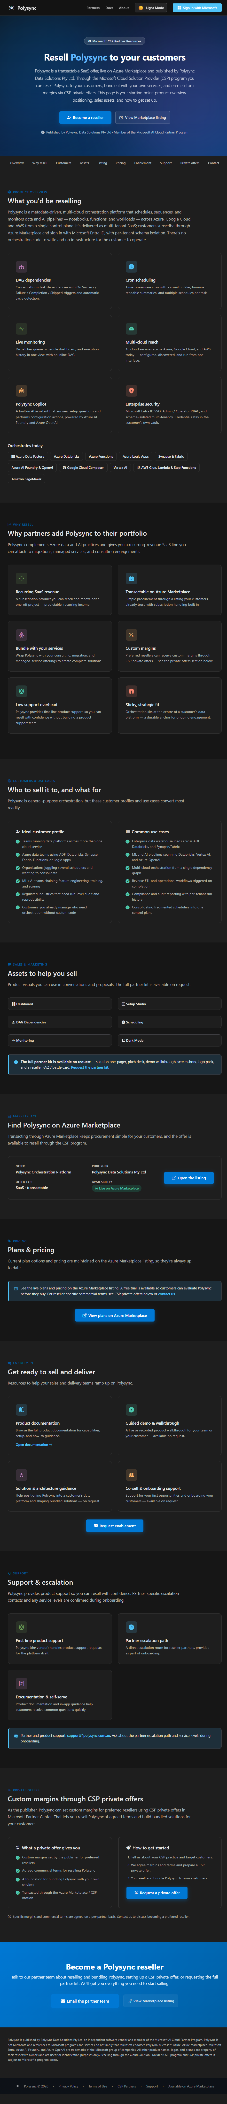
CSP partner program — resell, bundle, and earn custom margins

7. Onboarding guide — step by step

7.1 Prerequisites
- Azure subscription with Owner/Contributor on the target resource group.
- Entra ID admin able to grant SSO consent.
- Marketplace purchase rights (CSP partner for resale via private offer).
- Target-platform credentials (service principal, PAT, or managed identity).

7.2 Deployment via Azure Marketplace
- Find "Polysync" on Azure Marketplace (publisher: Polysync Data Solutions Pty Ltd).
- Subscribe and select a plan; provisioning is automatic — no infrastructure to deploy.
- CSP: transact via private offer to apply custom margin and register the tenant for billing.

7.3 Initial configuration
- Open the workspace and sign in with Microsoft Entra ID.
- Add platforms; test connectivity per platform.
- Bind a secret vault (Azure Key Vault, AWS Secrets Manager, GCP Secret Manager, HashiCorp) or let Polysync hold the credential in its managed Key Vault.

7.4 First pipeline setup
- Import jobs from a connected platform (discovered with parameters).
- Create tasks and configure parameters.
- Add dependencies and triggers; confirm the DAG has no cycles.
- Attach a CRON schedule; run on demand and validate.

7.5 Monitoring and operations
- Watch the dispatcher queue and schedule dashboard; drill into execution history.
- Configure retries; use health checks; resolve failures from one view.

7.6 Troubleshooting basics
Most first-run issues fall into three buckets. Connectivity: if a platform test fails, confirm the credential type matches the platform (service principal vs PAT vs managed identity) and that the secret resolves from the bound vault. Discovery gaps: if jobs do not appear, verify the credential has list/read scope on the target resource. Schedules not firing: confirm the schedule is active, the timezone is correct, and the dispatcher shows the task queued. When stuck, ask Polysync Copilot — it can read the current configuration and suggest the fix in context.

8. Partner enablement playbook
Introduce. Lead with pain, not features. Open with the patterns every multi-cloud data team recognizes: a scheduler per service, no dependencies across clouds, custom glue that never stops, and no single view of what is running right now. When the customer nods, you have permission to position the control plane.
Discovery questions. Use these to qualify and to size a POC: How many clouds are in play, and which execution engines? How many schedulers and triggers does the team maintain? How are cross-cloud dependencies handled today — timers, webhooks, or a person watching a screen? How do you find out a run failed, and how long to root cause? What audit and data-residency obligations apply? Who owns pipelines — one central team or many?
Demo flow. Keep it to fifteen minutes: open the setup studio and register a platform; import jobs and show parameters discovered automatically; build a small cross-cloud DAG with an On-Failure trigger; attach a CRON schedule; run it; switch to monitoring and drill into a run. Close by asking Polysync Copilot to explain or change a setting live.
Proof of concept. Scope two to four weeks on one real cross-cloud chain the customer already struggles with. Success criteria: an unattended scheduled run that sequences at least two clouds, plus single-pane monitoring with a working failure path. A tight, outcome-based POC converts far better than an open-ended pilot.

9. Use cases and scenarios
1. Data platform modernization. Problem: siloed schedulers and tribal knowledge slow every release. Solution: import existing jobs, model dependencies once, schedule centrally. Outcome: roughly 60% faster pipeline delivery and a single timeline the whole team trusts.
2. Multi-cloud orchestration. Problem: an ADF copy, a Databricks transform, and an AWS step are chained with brittle webhooks. Solution: one cross-cloud DAG with conditional triggers and cycle detection. Outcome: deterministic sequencing and no more 2 a.m. glue failures.
3. Migration acceleration. Problem: during a cloud migration the team must dual-run pipelines and prove parity. Solution: both source and target platforms orchestrated in one plane with side-by-side monitoring. Outcome: a lower-risk, observable cutover.
4. Operational automation. Problem: failures are reruns by hand and discovered by stakeholders. Solution: automatic retries, alerting, and a live dispatcher queue. Outcome: roughly 80% less manual toil and faster MTTR.
5. Hybrid with HashiCorp Vault. Problem: on-prem systems need credentials that must never leave the data center. Solution: vault-backed runs draw secrets at execution time from the customer's own vault. Outcome: hybrid orchestration with zero credential exposure.

10. Security, compliance, and trust
Security is a sales asset, not a checkbox. Use these talking points to reassure enterprise and regulated buyers:
- Identity: Microsoft Entra ID SSO for users; per-service managed identities for platform-to-platform calls; Admin/Operator RBAC so operators run without holding configuration rights.
- Isolation: schema-per-tenant separation keeps each customer's metadata and runs apart; credentials remain in the customer's own vault (Azure Key Vault, AWS Secrets Manager, GCP Secret Manager, or HashiCorp) and are read only at execution time.
- Network: Key Vault, VNet integration, and private endpoints protect in-scope data paths so SQL and secrets are not exposed publicly in production.
- Auditability: Application Insights and Log Analytics plus in-app execution history give a complete, queryable record of who ran what, when, and with which result.
- Responsible AI: Polysync Copilot uses Azure OpenAI inside the platform's own subscription; prompts are not used to train Microsoft models, and no other LLM provider is used. Customer data does not leave the Polysync Azure subscription for the AI feature.
For enterprise reviews, the headline is simple: Polysync adds orchestration without adding new credential sprawl, and everything runs on the Microsoft trust boundary the customer already accepts.

11. Conclusion & next steps
Polysync turns multi-cloud fragmentation into one governed, observable control plane — without rip-and-replace — and is buyable and resaleable through Microsoft. For CSP partners: (1) enable sales/pre-sales with this guide, (2) register as a reseller, (3) run a 2–4 week POC with one target account, (4) attach to migration and managed-service deals.

Appendix A — glossary
- Job: a resource discovered on a connected platform (e.g., an ADF pipeline).
- Task: a configured run of a job with parameters, schedule, and dependencies.
- DAG: directed acyclic graph of task dependencies.
- Dispatcher: resolves dependencies and executes tasks; enforces concurrency/rate limits.
- MACC: Microsoft Azure Consumption Commitment.
- CSP: Cloud Solution Provider program.

Appendix B — partner quick-reference card
- Pitch: one control plane for multi-cloud data + AI; keep tools, manage together.
- Buy: Azure Marketplace; resell via CSP private offer; counts toward MACC.
- Hooks: ~60% less build, ~80% less scheduling, one audit/monitor pane.
- ICP: multi-cloud, 500+, regulated, data team, migrating.
- First step: become a reseller, then run a POC on one cross-cloud chain.

